MONTHLY PROBLEM: SEPTEMBER

A census taker approaches a house and asks the woman who answers the door "How many children do you have, and what are their ages?"

Woman: "I have three children, the product of their ages are 36, the sum of their ages are equal to the address of the house next door."

The census taker walks next door, comes back and says "I need more information."

The woman replies "I have to go; my oldest child is sleeping upstairs."
Census taker: "Thank you, I now have everything I need."

What are the ages of each of the three children?
MONTHLY PROBLEM: OCTOBER

Beth, Carol and George love reading their favourite bedtime story together.

They take it in turns to read a page, always in the order Beth, then Carol, then George.

All twenty pages of the story are read on each occasion.

One evening, Beth is staying at Grandma’s house but Carol and George still read the same story and take it in turns to read a page with Carol reading the first page.

In total, how many pages are read by the person who usually reads that page?

MONTHLY PROBLEM: NOVEMBER

In a sale, an item is reduced by 20% and as a result makes only a 4% profit on the cost to the shop-keeper.

What percentage profit would the shop-keeper have made if the item had sold at full price?

MONTHLY PROBLEM: DECEMBER

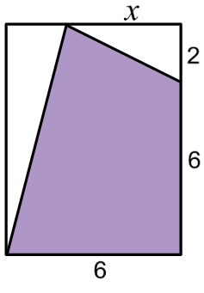

Three-quarters of the area of the rectangle has been shaded.

What is the value of x?

MONTHLY PROBLEM: JANUARY

The parallelogram shown in the diagram has been divided into nine smaller parallelograms.

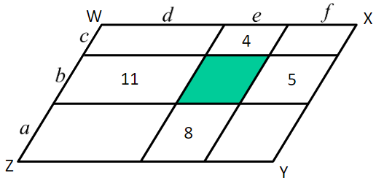

The perimeters, in cm, of four of the smaller parallelograms are shown. The perimeter of WXYZ is 21cm.

What is the perimeter of the shaded parallelogram?

MONTHLY PROBLEM: FEBRUARY

The area of JGK is 20cm²

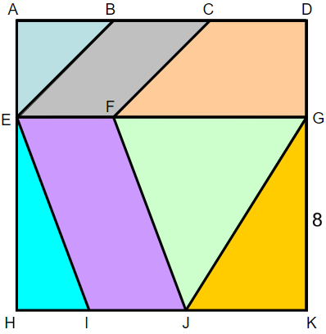

Can you find the areas of every other shape?

- ADHK is a square, length 12 cm
- AB = BC = CD = AE
- BE is parallel to CF
- EI is parallel to FJ
- GE is parallel to AD

MONTHLY PROBLEM: MARCH

Three identical squares overlap as shown.

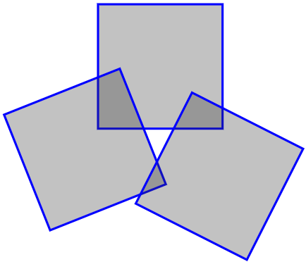

The areas of overlapping sections are 2cm², 5cm² and 8cm².

The areas of the non-overlapping parts of the squares are 117cm².

What are the lengths of the sides of the squares?

MONTHLY PROBLEM: APRIL

The diagram shows a square with side length 1, divided into four rectangles whose areas are equal.

What is the length labelled x?

MONTHLY PROBLEM: MAY

The diagram shows 15 identical circles, arranged in a rectangle, and a shaded triangle.

The vertices of the triangle are at the centre of the circles.

Calculate the area of the shaded triangle.

MONTHLY PROBLEM: JUNE

The diagrams show a table with two identical wooden blocks.

Calculate the height of the table.

40cm
52cm

MONTHLY PROBLEM: JULY

A circle is inscribed in an equilateral triangle.

1

Find the area of the triangle.

